
PATUAKHALI SCIENCE AND TECHNOLOGY UNIVERSITY
COURSE CODE CCE-224

SUBMITTED TO:

Prof. Dr. Md Samsuzzaman

Department of Computer and Communication Engineering
Faculty of Computer Science and Engineering

SUBMITTED BY:
Md. Sharafat Karim
ID: 2102024,
Registration No: 10151
Faculty of Computer Science and Engineering

Date of submission: 06 Thu, 2025
Assignment 03
Assignment title: ER diagrams

- University Management system
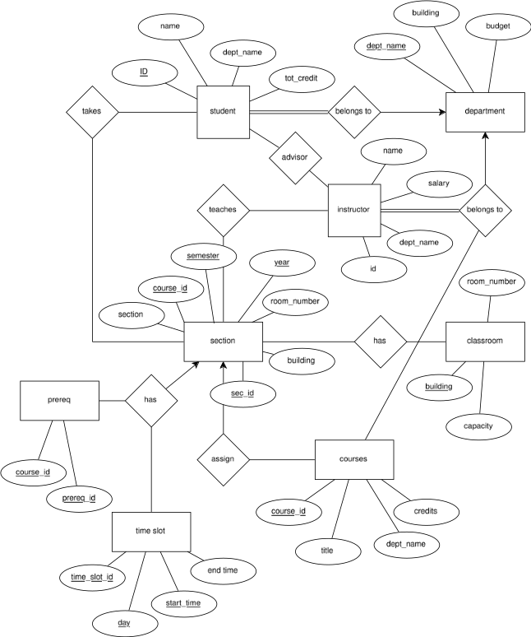
- ER Diagram of Hotel Management System
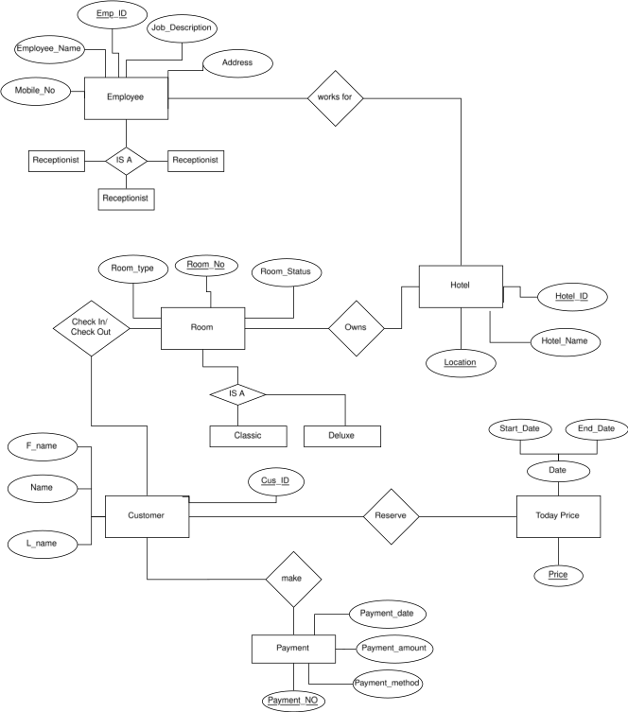
- ER Diagram of Library Management System
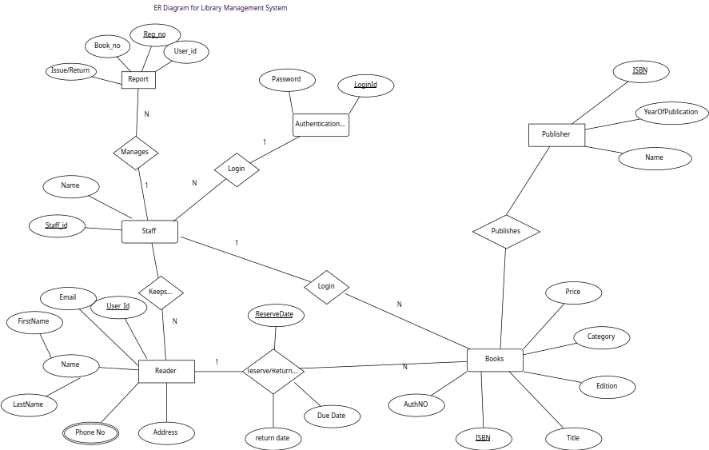
- ER Diagram of Online Shopping System

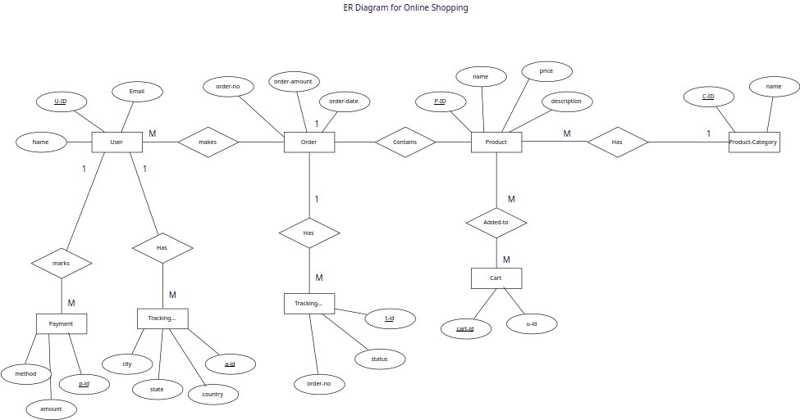
- ER Diagram of NoSQL Database

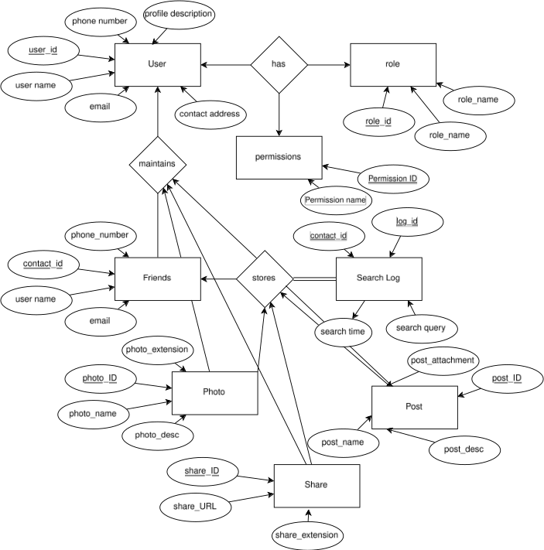
- ER Diagram of One-to-Many Relationship

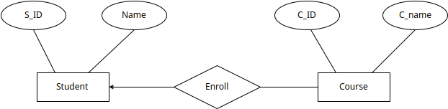
- ER Diagram of Banking System

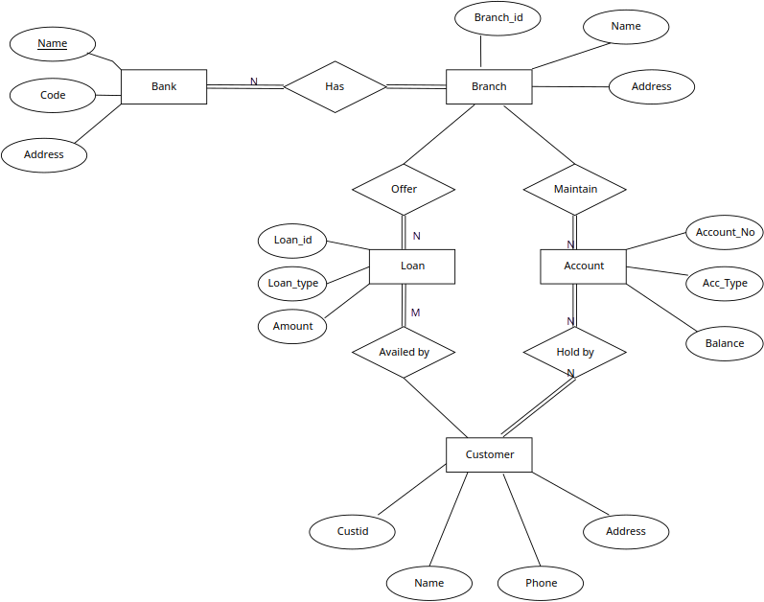
- ER Diagram of Hospital Management System

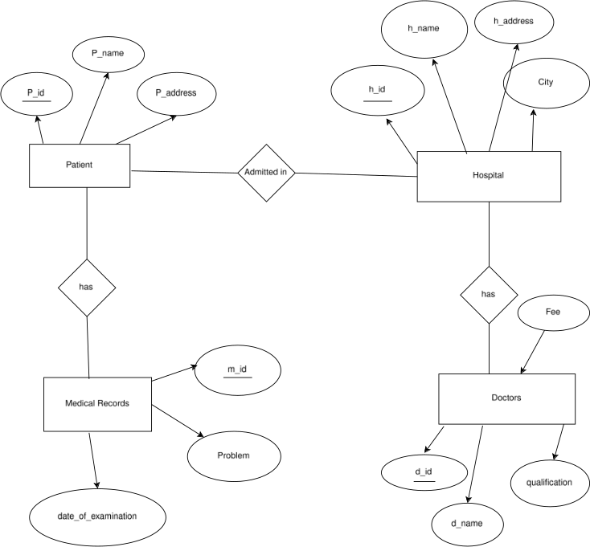
- Telephone directory Management system
